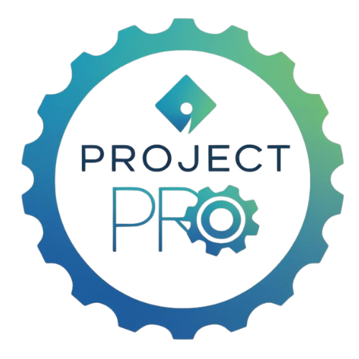
Section 2: Getting Started –
Initiating the Project

Step 1: Finding the Problem or Opportunity
Every successful project starts with a clear, meaningful idea. In this step, your goal is to identify a problem that needs solving or an opportunity to improve something. Think of this as laying the foundation for your entire project—if your foundation is solid, everything else will be stronger.
Look for issues in your school, community, or local businesses. Ask questions like: What’s not working as well as it could? What do people often wish were different? What could your DECA chapter help improve? Sometimes opportunities appear in everyday routines.
For example, maybe your school’s morning car line takes forever, or a local business has a hard time hiring part-time employees. Or perhaps students in your community struggle with budgeting their money or planning for college expenses. Any of these can become the starting point for a meaningful DECA project.
Here are a few project examples to spark your creativity:
- A small coffee shop near campus struggles with incorrect orders during busy times. You could design a new digital order system or training process to improve accuracy.
- Your town’s food bank receives fewer donations in the summer. You could launch a seasonal awareness campaign and collection drive.
- Your classmates don’t understand student loans or credit scores. You could organize a financial literacy event or mini-course for seniors.
Once you’ve found a potential problem, talk about it with your teammates, advisor, or community partners. Ask whether the problem feels realistic for your timeline and resources. Great ideas are exciting, but you’ll want one that’s doable within the school year.
Pro Tip: The best projects start small but grow in impact. Focus on one need and do it really well!

Step 2: Writing a Strong Problem Statement
After identifying your focus, describe it clearly and concisely. A strong problem statement explains what’s happening, who it affects, and why it matters. It also points toward what your project will do to help.
Think of it as the heart of your project. Anyone reading it should understand your purpose within a few sentences.
A solid problem statement includes three parts:
1. The current situation – What’s happening now.
2. The problem or need – What’s not working or missing.
3. The impact – Why it’s important to fix.
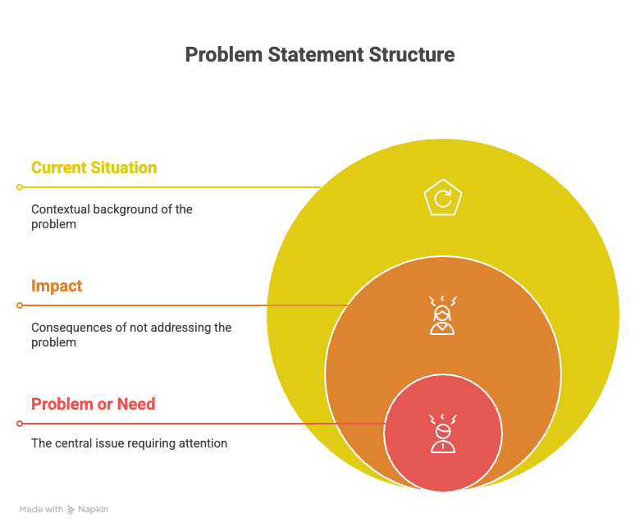
Here’s an example from a Career Development Project:
“Many students at Lincoln High School are unaware of the career options available in marketing and entrepreneurship. This lack of awareness makes it difficult for them to choose relevant high school courses and plan for future opportunities. Our project aims to increase student knowledge of marketing and business careers through a Career Exploration Fair featuring local professionals.”
Notice how this statement explains the situation, identifies the gap, and describes the action the team will take. When you write your own, imagine explaining it to someone outside your school. If they can easily understand the issue and why it matters, you’re on the right track.
Pro Tip: Use data or observations to make your statement stronger. For example, include results from a quick student survey or business interview.

Step 3: Setting the Project Scope
Your project scope defines what your project includes—and what it doesn’t. It’s your project’s boundaries, helping you stay focused and avoid doing too much. A scope statement briefly describes your purpose, rationale, and expected benefits.
Example (Community Awareness Project):
“Our project will raise awareness about distracted driving among high school students. We’ll design posters, host an assembly, and run a social media campaign encouraging safe driving. The project will run for one month and focus on students in grades 9–12. We will not collect surveys or driver data; our focus is strictly awareness.”
By clearly describing what’s inside and outside your scope, you make your project more achievable and measurable.
Pro Tip: Limit your scope to what you can control. It’s better to deliver one excellent project than several half-finished ideas.

Step 4: Keeping It Realistic
Ambition is great, but realism wins competitions. Many teams try to take on too much and run out of time. Use these questions to check if your idea is realistic:
- Do we have enough time to complete this project?
- Do we have access to the people, space, or materials we need?
- Can we make an impact that’s measurable, even if it’s small?
If you answered ‘no’ to any question, simplify your plan. Judges prefer smaller, well-run projects over large, incomplete ones.

Step 5: Documenting Your Work
From day one, start keeping records of your meetings, communications, and research. Think of this as your project diary—it’ll make writing your final report much easier.
Keep copies of:
- Meeting notes or agendas
- Emails or text summaries about project ideas
- Research articles or websites you reviewed
- Brainstorming notes or photos of planning boards
Pro Tip: Create a shared folder in Google Drive or OneDrive for your team. Organize it with subfolders for meetings, photos, finances, and final materials.

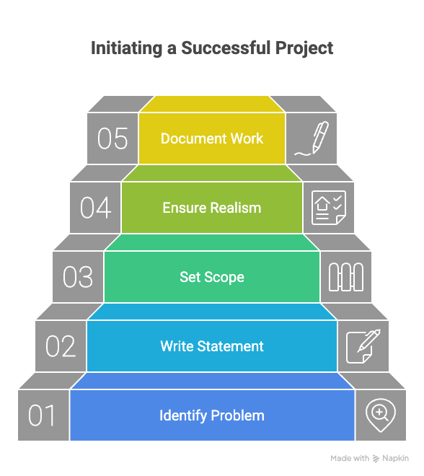

Reflection and Readiness Checklist
Before moving on to the next phase, reflect on your progress and check your readiness.
- What inspired your team to choose this problem or opportunity?
- How confident are you that your project idea is realistic?
- What early feedback did you receive from your advisor or partners?

Readiness Checklist:
- A clearly defined problem or opportunity
- A strong, specific problem statement
- A written project scope outlining purpose, rationale, and benefits
- Approval from advisor or chapter leadership to move forward

