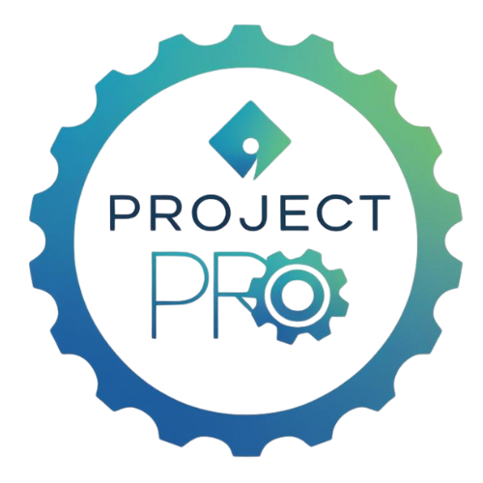

Defining the Project Scope:

Staying Focused and Realistic
When you start your DECA project, it’s easy to get excited and want to do everything. You might brainstorm ten amazing ideas, and your team starts saying, “We can do all of these!” But here’s the truth: great project managers know that less is often more.
The “scope” of your project is what defines your focus. It’s like putting borders on a map so you don’t accidentally wander into another country without realizing it. The project scope clearly states what’s included — the goals, activities, resources, and outcomes — and what’s not included.
When your scope is clear, your team knows exactly where to put their energy. When it’s not… things can get messy fast.

What “Project Scope” Really Means
Your project scope tells your team and your advisor exactly what your project covers. It answers questions like:
- What problem are we solving?
- What results are we trying to achieve?
- What actions are we taking to get there?
- What won’t we do as part of this project?
Think of it as your project’s “rulebook.” It keeps everyone on the same page so you don’t waste time chasing side ideas that don’t support your main goal.
Here’s a simple example:
Project idea: “We want to increase school spirit.”
That’s a great start — but it’s too big. You could design new shirts, plan pep rallies, run social media contests, decorate the halls, organize games, and more. That’s a lot.
Now, if you define your project scope, you might say:
“Our project will focus on designing and selling new spirit wear to raise school pride and support our DECA chapter.”
Now you’ve narrowed it down to something achievable. You’re focusing on one strategy — selling merchandise — instead of trying to do everything related to school spirit.

⚠️ What Happens When You Don’t Define Your Scope (a.k.a. Scope Creep)
Let’s talk about something every real project manager fears: scope creep.
“Scope creep” happens when your project keeps growing — usually because your team keeps saying “yes” to new ideas that sound cool, but weren’t part of the original plan.
Here’s what that looks like in a DECA project:
Your team starts with one clear goal:
“We’re going to host a financial literacy workshop for seniors.”
Perfect! It’s focused, meaningful, and doable.
But then someone says, “Hey, what if we also do a podcast about saving money?”
Another member adds, “We could make a YouTube series!”
Then someone else says, “Let’s visit the middle school and teach them, too!”
All of a sudden, you’ve gone from planning a one-day workshop to launching a full-blown multimedia campaign that takes weeks to prepare. Now your timeline is unrealistic, your team is overwhelmed, and your final product might end up rushed or incomplete.
That’s scope creep — and it happens when you don’t have a clear, written scope to guide decisions.
Real project managers deal with this all the time. In businesses, it can cost thousands of dollars and cause entire projects to fail. In your DECA project, it can cost you time, organization, and the quality of your results.
The best way to stop scope creep is simple:
Write your project scope early, share it with your advisor, and check back on it any time you’re tempted to add something new.
If a new idea doesn’t fit your original purpose or timeline, save it for next year’s project!

How to Write a Simple but Strong Scope Statement
A good project scope statement can be short — even just a few sentences.
It should explain:
- Purpose: Why are you doing this project?
- Goals: What do you hope to achieve?
- Boundaries: What’s included and what’s not?
- Resources: What time, money, and people are available?
Here’s an example from a Community Awareness Project:
“Our project will raise awareness about distracted driving among high school students. We will create posters, host an assembly with a guest speaker, and run a social media campaign for one month. We will not collect survey data or expand beyond our school community. Our team will stay within a $100 budget.”
That’s it! In four sentences, you’ve made it crystal clear what you’ll do — and what you won’t do.

Your Mini Scope Checklist
Use this checklist to make sure your project scope is realistic and well-defined:
Area | Questions to Ask | Example
Time | How long will this project take? Do we have enough weeks to do it well? | “Can we realistically plan, promote, and run this event before regionals?”
Budget | How much money or materials do we need? Do we have sponsors or funds available? | “We’ll keep our budget under $150 by using school printing and asking for donations.”
Team Roles | Does each team member have a defined responsibility? | “One person manages communication, another handles design, another tracks expenses.”
Deliverables | What will we produce at the end of this project? | “Three posters, one event, and one data summary report.”
Boundaries | What won’t we do (even if we have good ideas)? | “We won’t add a second event or expand beyond our school.”
If you can confidently answer each question, your project scope is solid.

A Final Thought: Stay Focused to Succeed
It’s easy to think that doing more means your project will be better. But judges don’t score you on how many different things you try — they score you on how effectively you manage your project.
A project that’s well-scoped shows maturity, leadership, and discipline. It tells the judges you know how to prioritize and deliver results.
Remember, you can always do more next year — but this year, focus on doing one thing exceptionally well.
So before you move on to the planning phase, take a moment with your team and ask:
“Is our project scope clear, focused, and realistic?”
If the answer is yes, you’re setting yourself up for a smooth, successful project that truly stands out.

Word count: ~755 words

