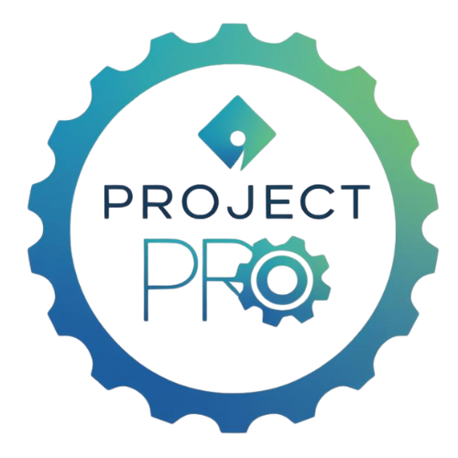

Initiating Phase Template: Define the Problem, Need, or Opportunity

Step 1: Project Overview
Project Title: ____________________________________________
DECA Category: [ ] Business Solutions [ ] Career Development [ ] Community Awareness [ ] Community Giving [ ] Financial Literacy [ ] Sales
Team Members: ____________________________________________
Advisor: ____________________________________________

Step 2: Identify the Problem or Opportunity
Describe what problem, need, or opportunity your project addresses and why it matters.
Example: Many students are unaware of scholarship opportunities, so we decided to increase awareness through a digital ‘Scholarship Hub.’
Write your description here...

Step 3: Define Who Benefits
Who will your project help? How will they benefit?
Describe your target audience...

Step 4: Problem or Opportunity Statement
Use this format: Our team identified that [problem/need]. We decided to [solution/action] to [intended impact].
Write your statement here...

Step 5: Project Scope
What's Included | What's Not Included
List included tasks... | List excluded tasks...

Step 6: Reflection Questions
• Have we clearly defined the problem or opportunity?
• Who benefits from our project?
• Is our scope realistic and achievable?

